Project Report

On

**TOURISM**

**MANAGEMENT SYSTEM**

**ACKNOWLEDGEMENT**

We take this occasion to thank God, almighty for blessing us with his grace and taking our Endeavour to a successful culmination. We extend our sincere and heart felt thanks to our esteemed guide, Mr. XYZ for providing us with the right guidance and advice at the crucial junctures and for showing us the right way. We extend our sincere thanks to our respected head of the division Mr.XYZ, for allowing us to use the facilities available. We would like to thank the other faculty members also, at this occasion. Last but not the least, we would like to thank friends for the support and encouragement they have given us during the course of our work.

**ABSTRACT**

As the name specifies “TOURISM MANAGEMENT SYSTEM” is software developed for managing tour booking.

Identification of the drawbacks of the existing system leads to the designing of computerized system that will be compatible to the existing system with the system Which is more user friendly and more GUI oriented. We can improve the efficiency of the system, thus overcome the drawbacks of the existing system.

* Less human error
* Strength and strain of manual labour can be reduced
* High security
* Data redundancy can be avoided to some extent
* Data consistency
* Easy to handle
* Easy data updating
* Easy record keeping
* Backup data can be easily generated

**INDEX**

* Objective
* Existing System
* Proposed System
* Study of the System
* Functional Requirement
* Number of Modules
* System Requirement
* Hardware Configuration
* Software Configuration
* Software Features
* PHP
* MYSQL
* PHPMYADMIN’
* Input Design
* Output Design
* SDLC Methodology
* DFD Diagrams
* UML Diagrams
* ER Diagrams
* Database Design
* Database Table and Structure of DB Tables
* Architecture Flow
* Output Screen of the Project (Screenshots)
* Conclusion
* Bibliography

**OBJECTIVE:**

* The objective of the project is to develop a system that automates the processes and activities of a travel and tourism agency.
* The purpose is to design a system using which one can perform all operations related to traveling and sight-seeing.

**EXISTING SYSTEM:**

* In the present system a customer has to approach various agencies to find details of places and to book tickets.
* This often requires a lot of time and effort.
* A customer may not get the desired information from these offices and often the customer may be misguided.
* It is tedious for a customer to plan a particular journey and have it executed properly.

**PROPOSED SYSTEM:**

* The proposed system is a web based application and maintains a centralized repository of all related information.
* The system allows one to easily access the relevant information and make necessary travel arrangements.
* Users can decide about places they want to visit and make bookings online for travel and accommodation.

# **STUDY OF THE SYSTEM:**

To provide flexibility to the users, the interfaces have been developed that are accessible through a browser. The GUI’S at the top level have been categorized as

1. Administrative user interface
2. The operational or generic user interface

The ‘administrative user interface’ concentrates on the consistent information that is practically, part of the organizational activities and which needs proper authentication for the data collection. These interfaces help the administrators with all the transactional states like Data insertion, Data deletion and Date updation along with the extensive data search capabilities.

The ‘operational or generic user interface’ helps the end users of the system in transactions through the existing data and required services. The operational user interface also helps the ordinary users in managing their own information in a customized manner as per the included flexibilities.

**FEASIBILITY STUDY:**

**FEASIBILITY REPORT:**

Preliminary investigation examines project feasibility; the likelihood the system will be useful to the organization. The main objective of the feasibility study is to test the Technical, Operational and Economical feasibility for adding new modules and debugging old running system. All systems are feasible if they are given unlimited resources and infinite time. There are aspects in the feasibility study portion of the preliminary investigation:

* Technical Feasibility
* Operation Feasibility
* Economical Feasibility

**TECHNICAL FEASIBILITY:**

The technical issue usually raised during the feasibility stage of the investigation includes the following:

* Does the necessary technology exist to do what is suggested?
* Do the proposed equipments have the technical capacity to hold the data required to use the new system?
* Will the proposed system provide adequate response to inquiries, regardless of the number or location of users?
* Can the system be upgraded if developed?
* Are there technical guarantees of accuracy, reliability, ease of access and data security?

**OPERATIONAL FEASIBILITY:**

Proposed projects are beneficial only if they can be turned out into information systems, which will meet the organization’s operating requirements. Operational feasibility aspects of the project are to be taken as an important part of the project implementation. Some of the important issues raised are to test the operational feasibility of a project includes the following: -

* Is there sufficient support for the management from the users?
* Will the system be used and work properly if it is being developed and implemented?
* Will there be any resistance from the user that will undermine the possible application benefits?

This system is targeted to be in accordance with the above-mentioned issues. Beforehand, the management issues and user requirements have been taken into consideration. So there is no question of resistance from the users that can undermine the possible application benefits.

The well-planned design would ensure the optimal utilization of the computer resources and would help in the improvement of performance status.

**ECONOMIC FEASIBILITY:**

A system can be developed technically and that will be used if installed must still be a good investment for the organization. In the economical feasibility, the development cost in creating the system is evaluated against the ultimate benefit derived from the new systems. Financial benefits must equal or exceed the costs. The system is economically feasible. It does not require any additional hardware or software.

# **FUNCTIONAL REQUIREMENTS:**

# **Number of Modules**

After careful analysis the system has been identified to have the following modules:

1. **Administrator module**
2. **User(Traveler) module**
3. **Guest user**

**1.ADMINISTRATOR MODULE:**

This module provides administrator related functionality. Administrator manages all information and has access rights to add, delete, edit and view the data related to places, travels, routes, bookings, Enquiries etc.

**Packages—**Admin will create the packages and Manage the packages(Create,Update,delete)

**Users-** Admin views all Information of all users.

**Booking-** Admin will responsible for manage booking. Admin can confirm and cancel a booking of traveler.

**Manage issues/ Complaints**—Admin can take action on any issue /complaint raised by user (traveller) and Put remark.

**Manage Enquiries—**admin can manage all enquiries raised by users(traveller).

**Manage pages-** Admin can edit the info of all pages that are display on the website,

**Dashboard-** Here admin can view all count of booking, issues , Enquiries and Users .

**Change password---** Admin can change own password.

**2.USER(TRAVELLER) MODULE:**

**Signup-** User can register your self for bookig.

**Sign in-** Here user can login with valid username and password.

**Forgot Password—**User can recover his/her own password.

**My Profile-** user can update own profile.

**Tour history-**After login user can book any tour that will show in Tour history. User can cancel his/her booking before 24 hr of travelling.

**Change Password---- User can own Password.**

**Write-use—Here user can raise any issue related to booking. Cancelation etc.**

**3.Guest MODULE:**

Guest user can visit the website and view the all content of website. Guest user can also Enquiry.

**SYSTEM ENVIRONMENT**

**2.1 Hardware Configuration**

1. Pentium IV Processor
2. 512 MB RAM
3. 40GB HDD
4. 1024 * 768 Resolution Color Monitor

**Note: This is not the “System Requirements”.**

**2.2 Software Configuration**

1. OS : Windows XP

2.PHP Triad (PHP5.6, MySQL, Apache, and PHPMyAdmin)

**2.3 Software Features**

**2.3.1 PHP TRIAD**

PHPTriad installs a complete working PHP/MySQL server environment on Windows platforms (9x/ NT). Installs PHP, MySQL, Apache, and PHPMyAdmin.

**2.3.1.1 PHP**

**PHP** is a scripting language originally designed for producing dynamic web pages. It has evolved toinclude a command line interface capability and can be used in standalone graphical applications. While PHP was originally created by RasmusLerdorf in 1995, the main implementation of PHP is now produced by **ThePHP Group** and serves as the*de facto*standard for PHP as there is no formal specification. PHP is freesoftware released under the PHP License, however it is incompatible with the GNU General Public License

(GPL), due to restrictions on the usage of the term *PHP*. It is a widely-used general-purpose scripting language that is especially suited for web development and can be embedded into HTML. It generally runs on a web server, taking PHP code as its input and creating web pages as output. It can be deployed on most web servers and on almost every operating system and platform free of charge. PHP is installed on more than 20 million websites and 1 million web servers.

*PHP* originally stood for Personal Home Page. It began in 1994 as a set of Common Gateway Interfacebinaries written in the C programming language by the Danish/Greenlandic programmer RasmusLerdorf. Lerdorf initially created these Personal Home Page Tools to replace a small set of Perl scripts he had been using to maintain his personal homepage. The tools were used to perform tasks such as displaying his résumé and recording how much traffic his page was receiving. He combined these binaries with his Form Interpreter to create PHP/FI, which had more functionality. PHP/FI included a larger implementation for the C programming language and could communicate with databases, enabling the building of simple, dynamic web applications.

Lerdorf released PHP publicly on June 8, 1995 to accelerate bug location and improve the code. This release was named PHP version 2 and already had the basic functionality that PHP has today. This included Perl-like variables, form handling, and the ability to embed HTML. The syntax was similar to Perl but was more limited, simpler, and less consistent. ZeevSuraski and Andi Gutmans, two Israeli developers at the Technion IIT, rewrote the parser in 1997 and formed the base of PHP 3, changing the language’s name to the recursive initialism *PHP: Hypertext Preprocessor*. The development team officially released PHP/FI 2 in November 1997 after months of beta testing. Afterwards, public testing of PHP 3 began, and the official launch came in June 1998. Suraski and Gutmans then started a new rewrite of PHP’s core, producing the Zend Engine in 1999. They also founded Zend Technologies in Ramat Gan, Israel.

On May 22, 2000, PHP 4, powered by the Zend Engine 1.0, was released. On July 13, 2004, PHP 5 was released, powered by the new Zend Engine II. PHP 5 included new features such as improved support for object-oriented programming, the PHP Data Objects extension (which defines a lightweight and consistent interface for accessing databases), and numerous performance enhancements. The most recent update released by The PHP Group is for the older PHP version 4 code branch.

In 2008, PHP 5 became the only stable version under development. Late static binding has been missing from PHP and will be added in version 5.3. PHP 6 is under development alongside PHP 5. Major changes include the removal of register_globals, magic quotes, and safe mode. The reason for the removals was because register_globals had given way to security holes, and magic quotes had an unpredictable nature, and was best avoided. Instead, to escape characters, Magic quotes may be substituted with the addslashes() function, or more appropriately an escape mechanism specific to the database vendor itself like mysql_real_escape_string() for MySQL.

PHP does not have complete native support for Unicode or multibyte strings; Unicode support will be included in PHP 6. Many high profile open source projects ceased to support PHP 4 in new code as of February 5, 2008, due to the GoPHP5 initiative, provided by a consortium of PHP developers promoting the transition from PHP 4 to PHP 5. It runs in both 32-bit and 64-bit environments, but on Windows the only official distribution is 32-bit, requiring Windows 32-bit compatibility mode to be enabled while using IIS in a 64-bit Windows environment. There is a third-party distribution available for 64-bit Windows.

**Usage**

PHP is a general-purpose scripting language that is especially suited for web development. PHP generally runs on a web server, taking PHP code as its input and creating web pages as output. It can also be used for command-line scripting and client-side GUI applications. PHP can be deployed on most web servers, many operating systems and platforms, and can be used with many relational database management systems. It is available free of charge, and the PHP Group provides the complete source code for users to build, customize and extend for their own use.

PHP primarily acts as a filter, taking input from a file or stream containing text and/or PHP instructions and outputs another stream of data; most commonly the output will be HTML. It can automatically detect the language of the user. From PHP 4, the PHP parser compiles input to produce bytecode for processing by the Zend Engine, giving improved performance over its interpreter predecessor. Originally designed to create dynamic web pages, PHP’s principal focus is server-side scripting,and it is similar to other server-side scripting.

languages that provide dynamic content from a web server to a client, such as Microsoft’s Active Server Pages, Sun Microsystems’ JavaServer Pages, and mod_perl. PHP has also attracted the development of many frameworks that provide building blocks and a design structure to promote rapid application develo-pment (RAD). Some of these include CakePHP, Symfony, CodeIgniter, and Zend Framework, offering features similar to other web application frameworks.

The LAMP architecture has become popular in the web industry as a way of deploying web applic-ations. PHP is commonly used as the *P* in this bundle alongside Linux, Apache and MySQL, although the *P* may also refer to Python or Perl.

As of April 2007, over 20 million Internet domains were hosted on servers with PHP installed, and PHP was recorded as the most popular Apache module. Significant websites are written in PHP including the user-facing portion of Facebook, Wikipedia (MediaWiki), Yahoo!, MyYearbook, , Digg, Wordpress and Tagged. In addition to server-side scripting, PHP can be used to create stand-alone, compiled applications and libraries, it can be used for shell scripting, and the PHP binaries can be called from the command line.

**2.3.1.1.1 Speed optimization**

As with many scripting languages, PHP scripts are normally kept as human-readable source code, even on production web servers. In this case, PHP scripts will be compiled at runtime by the PHP engine, which increases their execution time. PHP scripts are able to be compiled before runtime using PHP compilers as with other programming languages such as C (the language PHP and its extensions are written in). Code optimizers aim to reduce the computational complexity of the compiled code by reducing its size and making other changes that can reduce the execution time with the overall goal of improving performance. The nature of the PHP compiler is such that there are often opportunities for code optimization, and an example of a code optimizer is the Zend Optimizer PHP extension.

Another approach for reducing overhead for high load PHP servers is using PHP accelerators. These can offer significant performance gains by caching the compiled form of a PHP script in shared memory to avoid the overhead of parsing and compiling the code every time the script runs.

**2.3.1.1.2 Security**

The National Vulnerability Database stores all vulnerabities found in computer software. The overall proportion of PHP-related vulnerabilities on the database amounted to: 12% in 2003, 20% in 2004, 28% in 2005, 43% in 2006, 36% in 2007, and 35% in 2008. Most of these PHP-related vulnerabilities can be exploited remotely: they allow hackers to steal or destroy data from data sources linked to the webserver (such as an SQL database), send spam or contribute to DOS attacks using malware, which itself can be installed on the vulnerable servers.

These vulnerabilities are caused mostly by not following best practice programming rules: technical security flaws of the language itself or of its core libraries are not frequent. Recognizing that programmers cannot be trusted, some languages include taint checking to detect automatically the lack of input validation which induces many issues. However, such a feature is being developed for PHP

Hosting PHP applications on a server requires a careful and constant attention to deal with these security risks. There are advanced protection patches such as Suhosin and Hardening-Patch, especially designed for web hosting environments. Installing PHP as a CGI binary rather than as an Apache module is the preferred method for added security. With respect to securing the code itself, PHP code can be obfuscated to make it difficult to read while remaining functional.

**2.3.1.1.3 Syntax**

<html>

<head>

<title>PHP Test </title>

</head>

<body>

**<?php echo “<p> Hello World </p>”; ?>**

</body></html>

Note : - Code in bold letters shows the PHP code embedded within HTML

PHP only parses code within its delimiters. Anything outside its delimiters is sent directly to the output and is not parsed by PHP. The most common delimiters are <?php and ?>, which are open and close delimiters respectively. <script language=”php”> and </script> delimiters are also available. Short tags can be used to start PHP code, <? or<?= (which is used to echo back a string or variable) and the tag to end PHP code, ?>. These tags are commonly used, but like ASP-style tags (<% or <%= and %>), they are less portable as they can be disabled in the PHP configuration. For this reason, the use of short tags and ASP-style tags is discouraged. The purpose of these delimiters is to separate PHP code from non-PHP code, including HTML.

Variables are prefixed with a dollar symbol and a type does not need to be specified in advance. Unlike function and class names, variable names are case sensitive. Both double-quoted (“”) and heredoc strings allow the ability to embed a variable’s value into the string. PHP treats newlines as whitespace in the manner of a free-form language (except when inside string quotes), and statements are terminated by a semicolon. PHP has three types of comment syntax: /* */ serves as block comments, and // as well as # are used for inline comments. The echo statement is one of several facilities PHP provides to output text (e.g. to a web browser).

In terms of keywords and language syntax, PHP is similar to most high level languages that follow the C style syntax. *If* conditions, *for* and *while* loops, and function returns are similar in syntax to languages such as C, C++, Java and Perl.

**2.3.1.1.4 Data types**

PHP stores whole numbers in a platform-dependent range. This range is typically that of 32-bit signed integers. Unsigned integers are converted to signed values in certain situations; this behavior is different from other programming languages. Integer variables can be assigned using decimal (positive and negative), octal, and hexadecimal notations. Floating point numbers are also stored in a platform-specific range. They can be specified using floating point notation, or two forms of scientific notation. PHP has a native Boolean type that is similar to the native Boolean types in Java

and C++. Using the Boolean type conversion rules, non-zero values are interpreted as true and zero as false, as in Perl and C++. The null data type represents a variable that has no value.The only value in the null data type is *NULL.* Variables of the “resource” type represent references to resources from external sources. These are typically created by functions from a particular extension, and can only be processed by functions from the same extension; examples include file, image, and database resources. Arrays can contain elements of any type that PHP can handle, including resources, objects, and even other arrays. Order is preserved in lists of values and in hashes with both keys and values, and the two can be intermingled. PHP also supports strings, which can be used with single quotes, double quotes, or heredoc syntax. The Standard PHP Library (SPL) attempts to solve standard problems and implements efficient data access interfaces and classes.

**2.3.1.1.5 Functions**

PHP has hundreds of base functions and thousands more from extensions. These functions are well documented on the PHP site, but unfortunately, the built-in library has a wide variety of naming conventions and inconsistencies. PHP currently has no functions for thread programming.

**Version 5.2 and earlier**

Functions are not first-class functions and can only be referenced by their name—directly or dynamically by a variable containing the name of the function. User-defined functions can be created at any time without being prototyped. Functions can be defined inside code blocks, permitting a run-time decision as to whether or not a function should be defined. Function calls must use parentheses, with the exception of zero argument class constructor functions called with the PHP new operator, where parentheses are optional. PHP supports quasi-anonymous functions through the create_function() function, although they are not true anonymous functions because anonymous functions are nameless, but functions can only be referenced by name, or indirectly through a variable $function_name();, in PHP.

**Version 5.3 and newer**

PHP gained support for first-class functions and closures. True anonymous functions are supported

functiongetAdder($x) using the following syntax:

function getAdder($x)

{

return function ($y) use ($x) { return $x + $y;

};

}

$adder =getAdder(8);

echo $adder(2); // prints “10”

Here, getAdder() function creates a closure using parameter $x (keyword “use” forces getting variable from context), which takes additional argument $y and returns it to the caller. Such a function can be stored, given as the parameter to another functions, etc. For more details see Lambda functions and closures RFC.

**2.3.1.1.6 Objects**

Basic object-oriented programming functionality was added in PHP 3. Object handling was completely rewritten for PHP 5, expanding the feature set and enhancing performance. In previous versions of PHP, objects were handled like primitive types. The drawback of this method was that the whole object was copied when a variable was assigned or passed as a parameter to a method. In the new approach, objects are referenced by handle, and not by value. PHP 5 introduced private and protected member variables and methods, along with abstract classes and final classes as well as abstract methods and final methods. It also introduced a standard way of declaring constructors and destructors, similar to that of other object-oriented languages such as C++, and a standard exception handling model.

Furthermore, PHP 5 added interfaces and allowed for multiple interfaces to be implemented. There are special interfaces that allow objects to interact with the runtime system. Objects implementing ArrayAccess can be used with array syntax and objects implementing Iterator or IteratorAggregate can be used with the foreach language construct. There is no virtual table feature in the engine, so static variables are bound with a name instead of a reference at compile time.

If the developer creates a copy of an object using the reserved word *clone*, the Zend engine will check if a __clone() method has been defined or not. If not, it will call a default __clone() which will copy the object’s properties. If a __clone() method is defined, then it will be responsible for setting the necessary properties in the created object. For convenience, the engine will supply a function that imports the properties of the source object, so that the programmer can start with a by-value replica of the source object and only override properties that need to be changed.

**2.3.1.1.7 Resources**

PHP includes free and open source libraries with the core build. PHP is a fundamentally Internet-aware system with modules built in for accessing FTP servers, many database servers, embedded SQL libraries such as embedded PostgreSQL, MySQL and SQLite, LDAP servers, and others. Many functions familiar to C programmers such as those in the stdio family are available in the standard PHP build. PHP has traditionally used features such as “magic_quotes_gpc” and “magic_quotes_runtime” which attempt to escape apostrophes

(‘) and quotes (“) in strings in the assumption that they will be used in databases, to prevent SQL injection attacks. This leads to confusion over which data is escaped and which is not, and to problems when data is not in fact used as input to a database and when the escaping used is not completely correct. To make code portable between servers which do and do not use magic quotes, developers can preface their code with a script to reverse the effect of magic quotes when it is applied.

PHP allows developers to write extensions in C to add functionality to the PHP language. These can then be compiled into PHP or loaded dynamically at runtime. Extensions have been written to add support for the Windows API, process management on Unix-like operating systems, multibyte strings (Unicode), cURL, and several popular compression formats. Some more unusual features include integration with Internet Relay Chat, dynamic generation of images and Adobe Flash content, and even speech synthesis. The PHP Extension Community Library (PECL) project is a repository for extensions to the PHP language. Zend provides a certification exam for programmers to become certified PHP developers.

**2.3.1.2 MY SQL**

What is a database? Quite simply, it’s an organized collection of data. A database management system (DBMS) such as Access, FileMaker Pro, Oracle or SQL Server provides you with the software tools you need to organize that data in a flexible manner. It includes facilities to add, modify or delete data from the database, ask questions (or queries) about the data stored in the database and produce reports summarizing selected contents.

MySQL is a multithreaded,multi-user SQL database management system(DBMS). The basic program runs as a server providing multi-user access to a number of databases.Originally financed in a similar fashion to the JBoss model, MySQL was owned and sponsored by a single for-profit firm, the Swedish company MySQLAB now a subsidiary of Sun Microsystem , which holds the copyright to most of the codebase. The project’s source code is available under terms of the GNU General Public Licence, as well as under a variety of proprietory agreements.

MySQL is a database.The data in MySQL is stored in database objects called tables.A table is a collections of related data entries and it consists of columns and rows.Databases are useful when storing information categorically. A company may have a database with the following tables: “Employees”, “Products”, “Customers” and “Orders”.

**2.3.1.2.1 Database Tables**

A database most often contains one or more tables. Each table is identified by a name (e.g. “Customers” or “Orders”). Tables contain records (rows) with data.

**2.3.1.2.2 Queries**

A query is a question or a request.WithMySQL, we can query a database for specific information and have a recordset returned.

**2.3.1.2.2.1 Create a connection to a database**

Before you can access data in a database, you must create a connection to the database.In PHP, this is done with the mysqli_connect() function.

**Syntax**

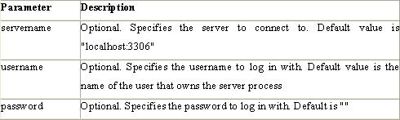

i

**Example**

In the following example we store the connection in a variable ($con) for later use in the script. The “die” part will be executed if the connection fails:

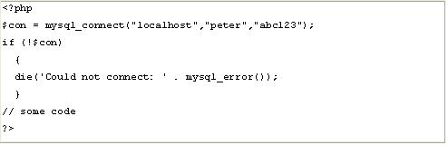

i

**2.3.1.2.2.2 Closing a Connection**

The connection will be closed automatically when the script ends. To close the connection before, use the mysqli_close() function:

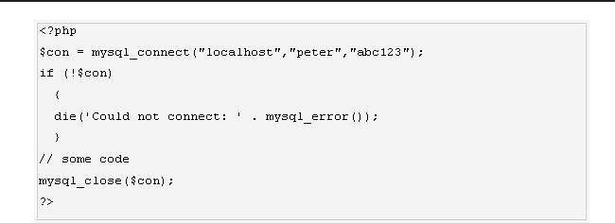

li

**2.3.1.2.2.3 Create a Database**

The CREATE DATABASE statement is used to create a database in MySQL.

**Syntax**

CREATE DATABASE database_name

To get PHP to execute the statement above we must use the mysql_query() function. This function is used to send a query or command to a MySQL connection.

**2.3.1.2.2.4 Create a Table**

The CREATE TABLE statement is used to create a table in MySQL

**Syntax**

CREATE TABLE table_name

(

column_name1 data_type, column_name2 data_type, column_name3 data_type,

*....*

)

**2.3.1.2.3 MySQL Functions**

mysql_affected_rows — Get number of affected rows in previous MySQL operation mysql_change_user — Change logged in user of the active connection mysql_client_encoding — Returns the name of the character set

mysql_close — Close MySQL connection mysql_connect — Open a connection to a MySQL Server mysql_create_db — Create a MySQL database mysql_data_seek — Move internal result pointer mysql_db_name — Get result data

mysql_db_query — Send a MySQL query mysql_drop_db — Drop (delete) a MySQL database

mysql_errno — Returns the numerical value of the error message from previous MySQL operation mysql_error — Returns the text of the error message from previous MySQL operation mysql_escape_string — Escapes a string for use in a mysql_query

mysql_fetch_array — Fetch a result row as an associative array, a numeric array, or both mysql_fetch_assoc — Fetch a result row as an associative array

mysql_fetch_field — Get column information from a result and return as an object mysql_fetch_lengths — Get the length of each output in a result mysql_fetch_object — Fetch a result row as an object

wsmysql_num_rows — Get number of rows in result mysql_pconnect — Open a persistent connection to a MySQL server

mysql_ping — Ping a server connection or reconnect if there is no connection mysql_query — Send a MySQL query

mysql_result — Get result data mysql_select_db — Select a MySQL database mysql_set_charset — Sets the client character set mysql_stat — Get current system status mysql_tablename — Get table name of field mysql_thread_id — Return the current thread ID

mysql_unbuffered_query — Send an SQL query to MySQL, without fetching and buffering the result (*See Appendix 2 for more My_SQL Functions.*)

**2.3.1.3 Macromedia Dreamweaver 8**

Is a professional HTML editor for designing, coding, and developing websites, web pages, and web applications. Whether you enjoy the control of hand-coding HTML or prefer to work in a visual editing environment, Dreamweaver provides you with helpful tools to enhance your web creation experience.

The visual editing features in Dreamweaver let you quickly create pages without writing a line of code. You can view all your site elements or assets and drag them from an easy-to-use panel directly into a document. You can streamline your development workflow by creating and editing images in Macromedia Fireworks or another graphics application, then importing them directly into Dreamweaver, or by adding Macromedia Flash objects.Dreamweaver also provides a full-featured coding environment that includes code-editing tools (such as code coloring and tag completion) and language reference material on Cascading Style Sheets (CSS), JavaScript, and ColdFusion Markup Language (CFML), among others. Macromedia Roundtrip HTML technology imports your hand-coded HTML documents without reformatting the code; you can then reformat code with your preferred formatting style. Dreamweaver also enables you to build dynamic database-backed web applications using server technologies such as CFML, ASP.NET, ASP, JSP, and PHP.

**2.3.1.3.1 Dreamweaver and accessibility**

Accessibility refers to making websites and web products usable for people with visual, auditory, motor, and other disabilities. Examples of accessibility features for software products and websites include screen reader support, text equivalents for graphics, keyboard shortcuts, change of display colors to high contrast, and so on. Dreamweaver provides tools that make the product accessible and tools that help you author accessible content:

**Using Dreamweaver accessibility features** For Dreamweaver web designers who need to useaccessibility features, Dreamweaver offers screen reader support, keyboard navigation, and operating system accessibility support.For more information, see Using Dreamweaver accessibility features.

**Authoring for accessibility** For Dreamweaver web designers who need to create accessible content,Dreamweaver assists you in creating accessible pages that contain useful content for screen readers and comply with government guidelines.

Dreamweaver provides dialog boxes that prompt you to enter accessibility attributes when you insert page elements (see Optimizing the workspace for accessible page design).For example, the accessibility dialog box for images reminds you to add text equivalents for graphics. Then, when the image appears on a page for a user with visual disabilities, the screen reader reads the description.

**2.3.1.3.2 Laying Out Pages with CSS**

In Macromedia Dreamweaver 8, you can use CSS styles to lay out your page. You can either insert div tags manually and apply CSS positioning styles to them, or you can use Dreamweaver layers to create your layout. A layer in Dreamweaver is an HTML page element—specifically, a div tag, or any other tag—that has an absolute position assigned to it. Whether you use CSS, tables, or frames to lay out your pages, Dreamweaver has rulers and grids for visual guidance in your layout. Dreamweaver also has a tracing image feature, which you can use to re-create a page design that was created in a graphics application.

**Client-side role of forms**

Forms support the client side of the client-server relationship. When a visitor enters information into a form displayed in a web browser (the client) and clicks the submit button, the information is sent to the server where a server-side script or application processes it. Common server-side technologies used for processing form data include Macromedia ColdFusion, Microsoft Active Server Pages (ASP), and PHP. The server responds by sending requested information back to the user (or client), or performing some action based on the form’s contents.

*( Note : - See Appendix 1 for more about Macromedia Dreamweaver 8 and phpMyAdmin)*

**2.3.1.4 phpMAdmin**

**phpMyAdmin**is an open source tool written in PHP intended to handle the administration of MySQLover the World Wide Web. phpMyAdmin supports a wide range of operations with MySQL.Currently it can create and drop databases, create/drop/alter tables, delete/edit/add fields, execute any SQL statement, manage users and permissions, and manage keys on fields. while you still have the ability to directly execute any SQL statement. phpMyAdmin can manage a whole MySQL server (needs a super-user) as well as a single database. To accomplish the latter you’ll need a properly set up MySQL user who can read/write only the desired database. It’s up to you to look up the appropriate part in the MySQL manual.

**phpMyAdmin can:**

* browse and drop databases, tables, views, fields and indexes
* create, copy, drop, rename and alter databases, tables, fields and indexes
* maintenance server, databases and tables, with proposals on server configuration
* execute, edit and bookmark any SQL-statement, even batch-queries
* load text files into tables
* create and read dumps of tables
* export data to various formats: CSV, XML, PDF, ISO/IEC 26300 - OpenDocument Text and Spreadsheet, Word, Excel and LATEX formats
* administer multiple servers
* manage MySQL users and privileges
* check referential integrity in MyISAM tables
* using Query-by-example (QBE), create complex queries automatically connecting required tables
* create PDF graphics of your Database layout
* search globally in a database or a subset of it
* transform stored data into any format using a set of predefined functions, like displaying BLOB-data as image or download-link
* support InnoDB tables and foreign keys
* support mysqli, the improved MySQL extension

**A word about users:**

Many people have difficulty understanding the concept of user management with regards

tophpMyAdmin. When a user logs in to phpMyAdmin, that username and password are passed directly to MySQL. phpMyAdmin does no account management on its own (other than allowing one to manipulate the MySQL user account information); all users must be valid MySQL users.

1) phpMyAdmin can compress (Zip, GZip -RFC 1952- or Bzip2 formats) dumps and CSV exports if you use PHP with Zlib support (—with-zlib) and/or Bzip2 support (—with-bz2). Proper support may also need changes in php.ini.aphpMyAdmin screen appears as shown below.

**2.3.1.4. 1 Requirements**

o **PHP**

1. You need PHP 5.2.0 or newer, with session support and the Standard PHP Library (SPL) extension.

o To support uploading of ZIP files, you need the PHP zip extension.

1. For proper support of multibyte strings (eg. UTF-8, which is currently default), you should install mbstring and ctype extensions.
2. You need GD2 support in PHP to display inline thumbnails of JPEGs (“image/jpeg: inline”) with their original aspect ratio
3. When using the “cookie” authentication method, the mcrypt extension is strongly suggested for most users and is required for 64–bit machines. Not using mcrypt will cause phpMyAdmin to load pages significantly slower.

**2.3.1.5 Apache Web server**

Often referred to as simply *Apache*, a public-domain open source Web server developed by a loosely-knit group of programmers. The first version of Apache, based on the NCSA httpd Web server, was developed in 1995.

Core development of the Apache Web server is performed by a group of about 20 volunteer programmers, called the *Apache Group.* However, because the source code is freely available, anyone can adapt the server for specific needs, and there is a large public library of Apache add-ons. In many respects, development of Apache is similar to development of the Linux operating system.

The original version of Apache was written for UNIX, but there are now versions that run under OS/ 2, Windows and other platforms. The name is a tribute to the Native American Apache Indian tribe, a tribe well known for its endurance and skill in warfare. A common misunderstanding is that it was called Apache because it was developed from existing NCSA code plus various patches, hence the name *a patchy server*, or Apache server.

Apache consistently rates as the world’s most popular Web server according to analyst surveys. Apache has attracted so much interest because it is full-featured, reliable, and free. Originally developed for UNIX™ operating systems, Apache has been updated to run on Windows, OS/2, and other platforms. One aspect of Apache that some site administrators find confusing — especially those unfamiliar with UNIX-style software — is its configuration scheme. Instead of using a point-and-click graphic user interface (GUI) or Windows Registry keys as most other

**Configuration Files**

Apache uses a system of three text files for managing its configuration data. All three of these files (almost always) appear in Apache’s ./conf directory and are designed to be edited by system administrators:

1. httpd.conf for general settings
2. srm.conf for resource settings
3. access.conf for security settings

When Apache first starts, these files are processed in the order shown above. Originally, the initial installation of Apache included default entries within each of the three files. In the most recent versions of Apache, however, the default installation has changed. Now httpd.conf is treated as the “master” configuration file and it contains all of the settings. Both srm.conf and access.conf still exist in the installation, but they contain no settings and are empty except for some comments.

**Inside Httpd.conf**

Traditionalyhttpd.conf contained general settings such as the ServerName and Port number.These entries appear as follows in the file: ServerName compnetworking.about.com Port 80 The term “httpd” stands for *HTTP Daemon*. Recall that in a UNIX environment, the term *daemon* refers to a type of process designed to launch at system boot and continue running for very long periods of time. This file contains a number of other entries (technically called directives), but for most of these,modifications are optional. Probably the most useful of these entries is ServerAdmin.

**Access and Security Settings**

It is recommended practice now for Apache administrators to manage their resource and security settings from httpd.conf. Administrators of older versions of Apache can simply cut their entries from srm.conf and access.conf and paste them into the master file. If an administrator wants to go one step further and delete the two empty files, they should also place the following entries in httpd.conf to prevent Apache from attempting to access them.

**INPUT DESIGN:**

Input design is a part of overall system design. The main objective during the input design is as given below:

* To produce a cost-effective method of input.
* To achieve the highest possible level of accuracy.
* To ensure that the input is acceptable and understood by the user.

**INPUT STAGES:**

The main input stages can be listed as below:

* Data recording
* Data transcription
* Data conversion
* Data verification
* Data control
* Data transmission
* Data validation
* Data correction

**INPUT TYPES:**

It is necessary to determine the various types of inputs. Inputs can be categorized as follows:

* External inputs, which are prime inputs for the system.
* Internal inputs, which are user communications with the system.
* Operational, which are computer department’s communications to the system?
* Interactive, which are inputs entered during a dialogue.

**INPUT MEDIA:**

At this stage choice has to be made about the input media. To conclude about the input media consideration has to be given to;

* Type of input
* Flexibility of format
* Speed
* Accuracy
* Verification methods
* Rejection rates
* Ease of correction
* Storage and handling requirements
* Security
* Easy to use
* Portability

Keeping in view the above description of the input types and input media, it can be said that most of the inputs are of the form of internal and interactive. As

Input data is to be the directly keyed in by the user, the keyboard can be considered to be the most suitable input device.

**OUTPUT DESIGN:**

Outputs from computer systems are required primarily to communicate the results of processing to users. They are also used to provide a permanent copy of the results for later consultation. The various types of outputs in general are:

* External Outputs whose destination is outside the organization.
* Internal Outputs whose destination is with in organization and they are the User’s main interface with the computer.
* Operational outputs whose use is purely with in the computer department.
* Interface outputs, which involve the user in communicating directly with the system.

**OUTPUT DEFINITION**

# The outputs should be defined in terms of the following points:

* + - Type of the output
    - Content of the output
    - Format of the output
    - Location of the output
    - Frequency of the output
    - Volume of the output
    - Sequence of the output

It is not always desirable to print or display data as it is held on a computer. It should be decided as which form of the output is the most suitable.

**For Example**

* Will decimal points need to be inserted
* Should leading zeros be suppressed.

**OUTPUT MEDIA:**

In the next stage it is to be decided that which medium is the most appropriate for the output. The main considerations when deciding about the output media are:

* The suitability for the device to the particular application.
* The need for a hard copy.
* The response time required.
* The location of the users
* The software and hardware available.

Keeping in view the above description the project is to have outputs mainly coming under the category of internal outputs. The main outputs desired according to the requirement specification are:

The outputs were needed to be generated as a hard copy and as well as queries to be viewed on the screen. Keeping in view these outputs, the format for the output is taken from the outputs, which are currently being obtained after manual processing. The standard printer is to be used as output media for hard copies.

**SDLC Methodology:**

This document play a vital role in the development of life cycle (SDLC) as it describes the complete requirement of the system. It means for use by developers and will be the basic during testing phase. Any changes made to the requirements in the future will have to go through formal change approval process.

SPIRAL MODEL was defined by Barry Boehm in his 1988 article, “A spiral Model of Software Development and Enhancement. This model was not the first model to discuss iterative development, but it was the first model to explain why the iteration models.

As originally envisioned, the iterations were typically 6 months to 2 years long. Each phase starts with a design goal and ends with a client reviewing the progress thus far. Analysis and engineering efforts are applied at each phase of the project, with an eye toward the end goal of the project.

The steps for Spiral Model can be generalized as follows:

* The new system requirements are defined in as much details as possible. This usually involves interviewing a number of users representing all the external or internal users and other aspects of the existing system.
* A preliminary design is created for the new system.
* A first prototype of the new system is constructed from the preliminary design. This is usually a scaled-down system, and represents an approximation of the characteristics of the final product.
* A second prototype is evolved by a fourfold procedure:

1. Evaluating the first prototype in terms of its strengths, weakness, and risks.
2. Defining the requirements of the second prototype.
3. Planning an designing the second prototype.
4. Constructing and testing the second prototype.

* At the customer option, the entire project can be aborted if the risk is deemed too great. Risk factors might involved development cost overruns, operating-cost miscalculation, or any other factor that could, in the customer’s judgment, result in a less-than-satisfactory final product.
* The existing prototype is evaluated in the same manner as was the previous prototype, and if necessary, another prototype is developed from it according to the fourfold procedure outlined above.
* The preceding steps are iterated until the customer is satisfied that the refined prototype represents the final product desired.
* The final system is constructed, based on the refined prototype.
* The final system is thoroughly evaluated and tested. Routine maintenance is carried on a continuing basis to prevent large scale failures and to minimize down time.

**The following diagram shows how a spiral model acts like:**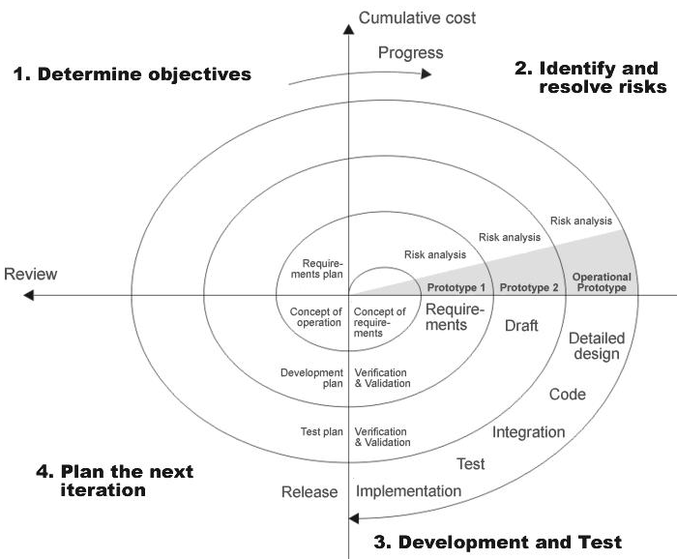

**Advantages:**

* Estimates(i.e. budget, schedule etc .) become more relistic as work progresses, because important issues discoved earlier.
* It is more able to cope with the changes that are software development generally entails.

Software engineers can get their hands in and start woring on the core of a project earlier

**Performance Requirements:**

Performance is measured in terms of the output provided by the application. Requirement specification plays an important part in the analysis of a system. Only when the requirement specifications are properly given, it is possible to design a system, which will fit into required environment. It rests largely with the users of the existing system to give the requirement specifications because they are the people who finally use the system. This is because the requirements have to be known during the initial stages so that the system can be designed according to those requirements. It is very difficult to change the system once it has been designed and on the other hand designing a system, which does not cater to the requirements of the user, is of no use.

The requirement specification for any system can be broadly stated as given below:

* The system should be able to interface with the existing system
* The system should be accurate
* The system should be better than the existing system

The existing system is completely dependent on the user to perform all the duties.

**DFD (Context level Diagram):a.Users**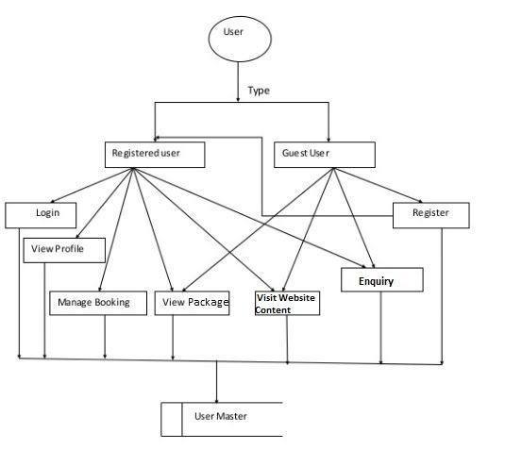

**b.Admin**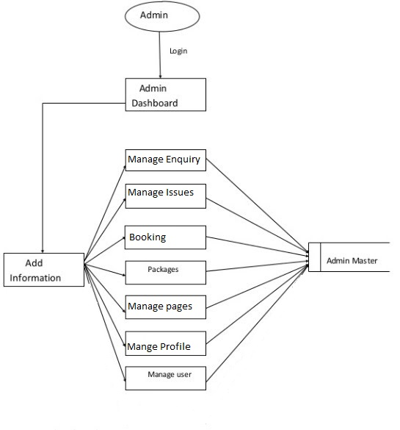

**C.**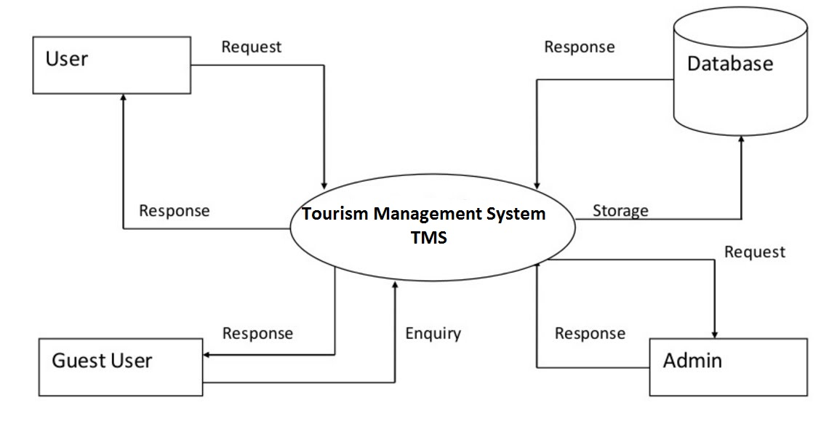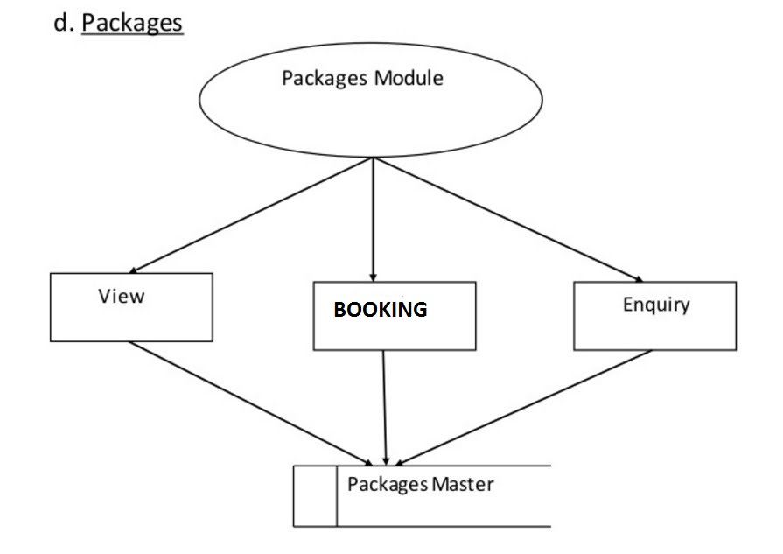

**UML Diagram**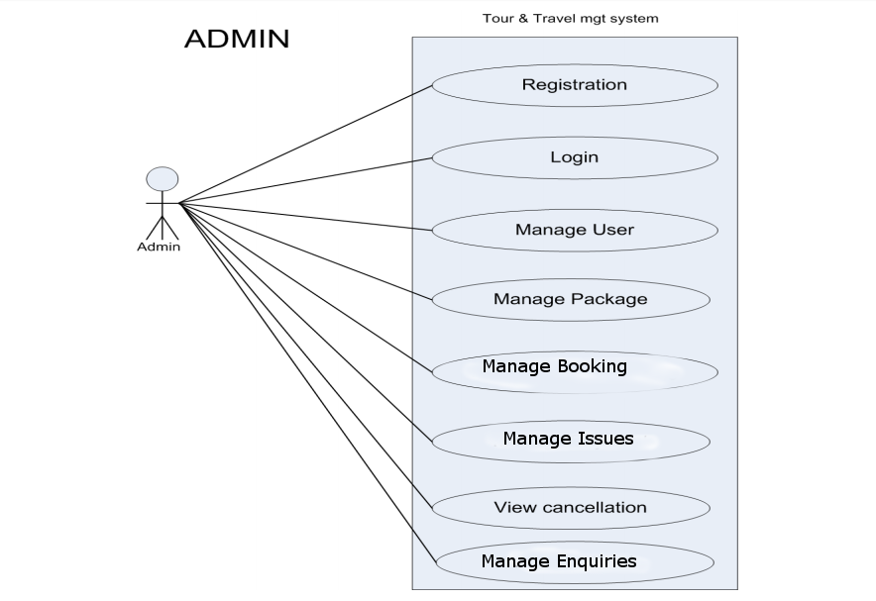

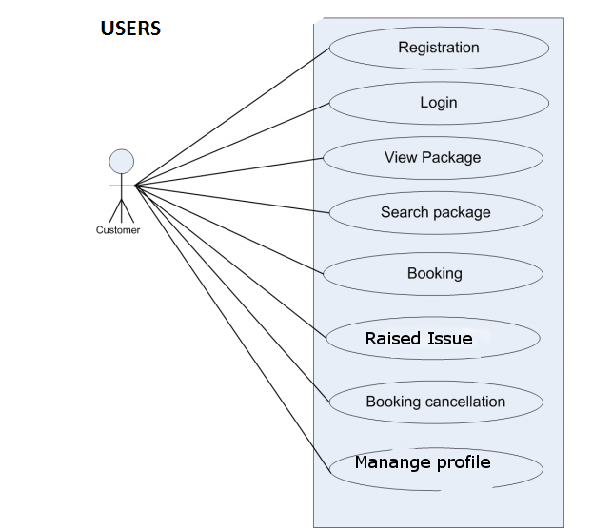

#### ENTITY-RELATIONSHIP Diagrams

E-R (Entity-Relationship) Diagram is used to represents the relationship between entities in the table.

The symbols used in E-R diagrams are:

SYMBOL PURPOSE

Represents Entity sets.

Represent attributes.

Represent Relationship Sets.

Line represents flow

Structured analysis is a set of tools and techniques that the analyst.

To develop a new kind of a system:

The traditional approach focuses on the cost benefit and feasibility analysis, Project management, and hardware and software selection a personal considerations.

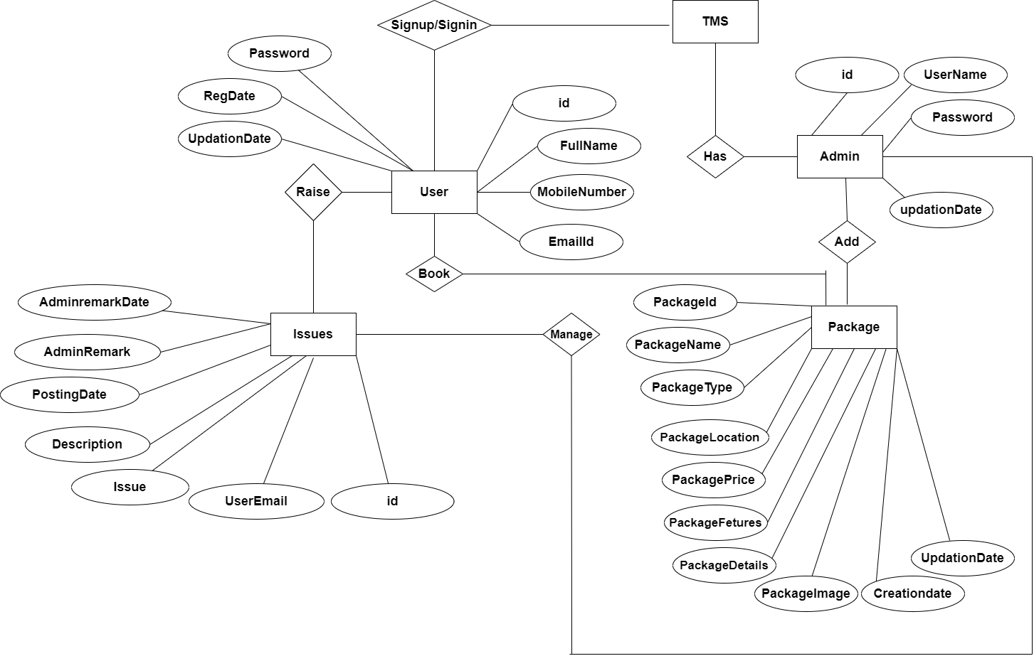

**Database Design**

The data in the system has to be stored and retrieved from database. Designing the database is part of system design. Data elements and data structures to be stored have been identified at analysis stage. They are structured and put together to design the data storage and retrieval system.

A database is a collection of interrelated data stored with minimum redundancy to serve many users quickly and efficiently. The general objective is to make database access easy, quick, inexpensive and flexible for the user. Relationships are established between the data items and unnecessary data items are removed. Normalization is done to get an internal consistency of data and to have minimum redundancy and maximum stability. This ensures minimizing data storage required, minimizing chances of data inconsistencies and optimizing for updates. The MySQL database has been chosen for developing the relevant databases.

**Database tables and Structure**

**Admin Table:** This table store the admin login details.

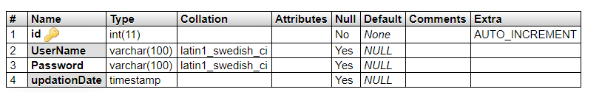

**tbluser table:** This table store the user personal and login details.

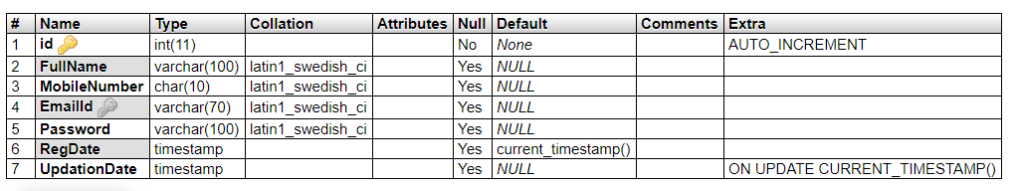

**tbltourpackages table:** This table store the tour package full details.

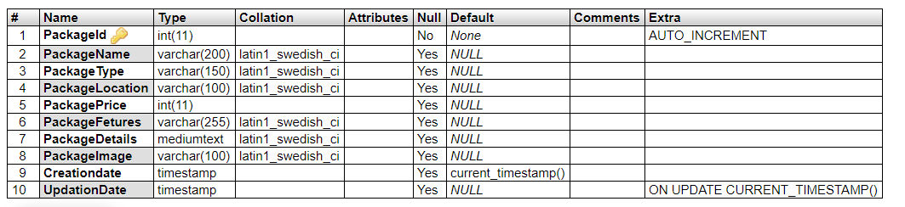

**tblbooking table:** This table store the user booking details.

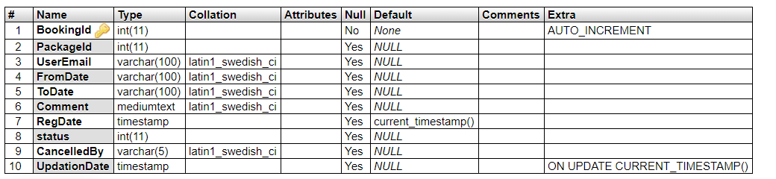

**tblissues table:** This table store the user issue details raised by the user.

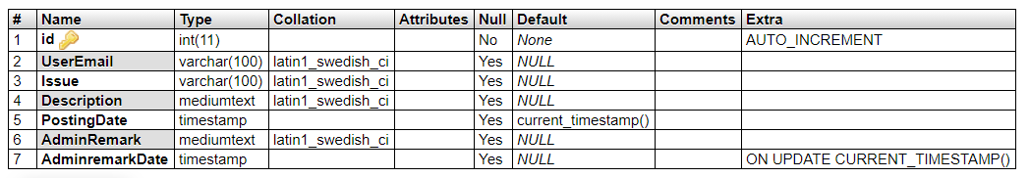

**tblenquiry table:** This table store the user enquiry details.

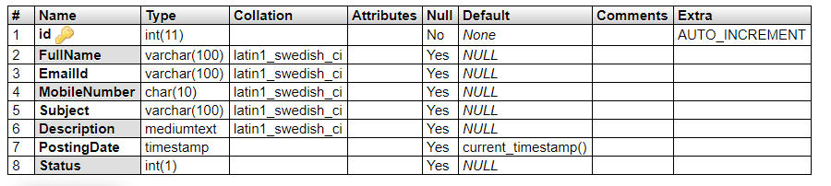

**tblpages table:** This table store the website pages details.

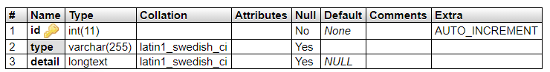

**Class Diagram**

The class diagram shows a set of classes, interfaces, collaborations and their relationships.

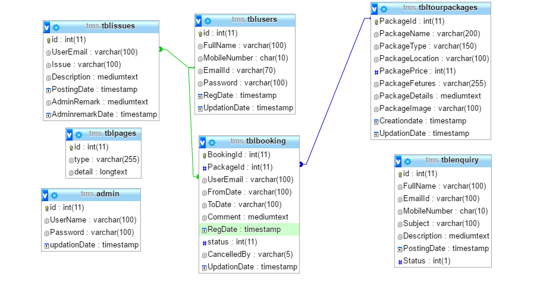

**Architecture flow :(N-Tier)**

N-Tier Applications can easily implement the concepts of Distributed Application Design and Architecture. The N-Tier Applications provide strategic benefits to Enterprise Solutions. While 2-tier, client-server can help us create quick and easy solutions and may be used for Rapid Prototyping, they can easily become maintenance and security night mare The N-tier Applications provide specific advantages that are vital to the business continuity of the enterprise. Typical features of a real life n-tier may include the following:

* Security
* Availability and Scalability
* Manageability
* Easy Maintenance
* Data Abstraction

The above mentioned points are some of the key design goals of a successful n-tier application that intends to provide a good Business Solution.

**Definition:**

Simply stated, an n-tier application helps us distribute the overall functionality into various tiers or layers:

* Presentation Layer
* Business Logic layer
* Data Link Layer
* Database/Data Store

Each layer can be developed independently of the other provided that it adheres to the standards and communicates with the other layers as per the specifications. This is the one of the biggest advantages of the n-tier application. Each layer can potentially treat the other layer as a ‘Block-Box’. In other words, each layer does not care how other layer processes the data as long as it sends the right data in a correct format.

**Business Logic Layer**

**Presentation Layer**

**Request**

**Response**

**Data Link**

**Layer**

**Data Base**

**Fig: N-Tier Architecture**

1. **Presentation Layer:**

Also called as client layer, comprises of components that are dedicated to presenting the data to the user. For example: Windows/Web Forms and buttons, edit boxes, Text boxes, labels, grids, etc.

1. **Business Logic Layer:**

This layer encapsulates the Business rules or the business logic of the encapsulations. To have a separate layer for business logic is of a great advantage. This is because any changes in Business Rules can be easily handled in this layer. As long as the interface between the layers remains the same, any changes to the functionality/processing logic in this layer can be made without impacting the others. A lot of client-server apps failed to implement successfully as changing the business logic was a painful process.

1. **Data Link Layer:**

This layer comprises of components that help in accessing the Database. If used in the right way, this layer provides a level of abstraction for the database structures. Simply put changes made to the database, tables, etc do not affect the rest of the application because of the Data Access layer. The different application layers send the data requests to this layer and receive the response from this layer.

1. **Database Layer:**

This layer comprises of the Database Components such as DB Files, Tables, Views, etc. The Actual database could be created using SQL Server, Oracle, Flat files, etc. In an n-tier application, the entire application can be implemented in such a way that it is independent of the actual Database. For instance, you could change the Database Location with minimal changes to Data Access Layer. The rest of the Application should remain unaffected.

**Output Screen of Project**

**Home Page**

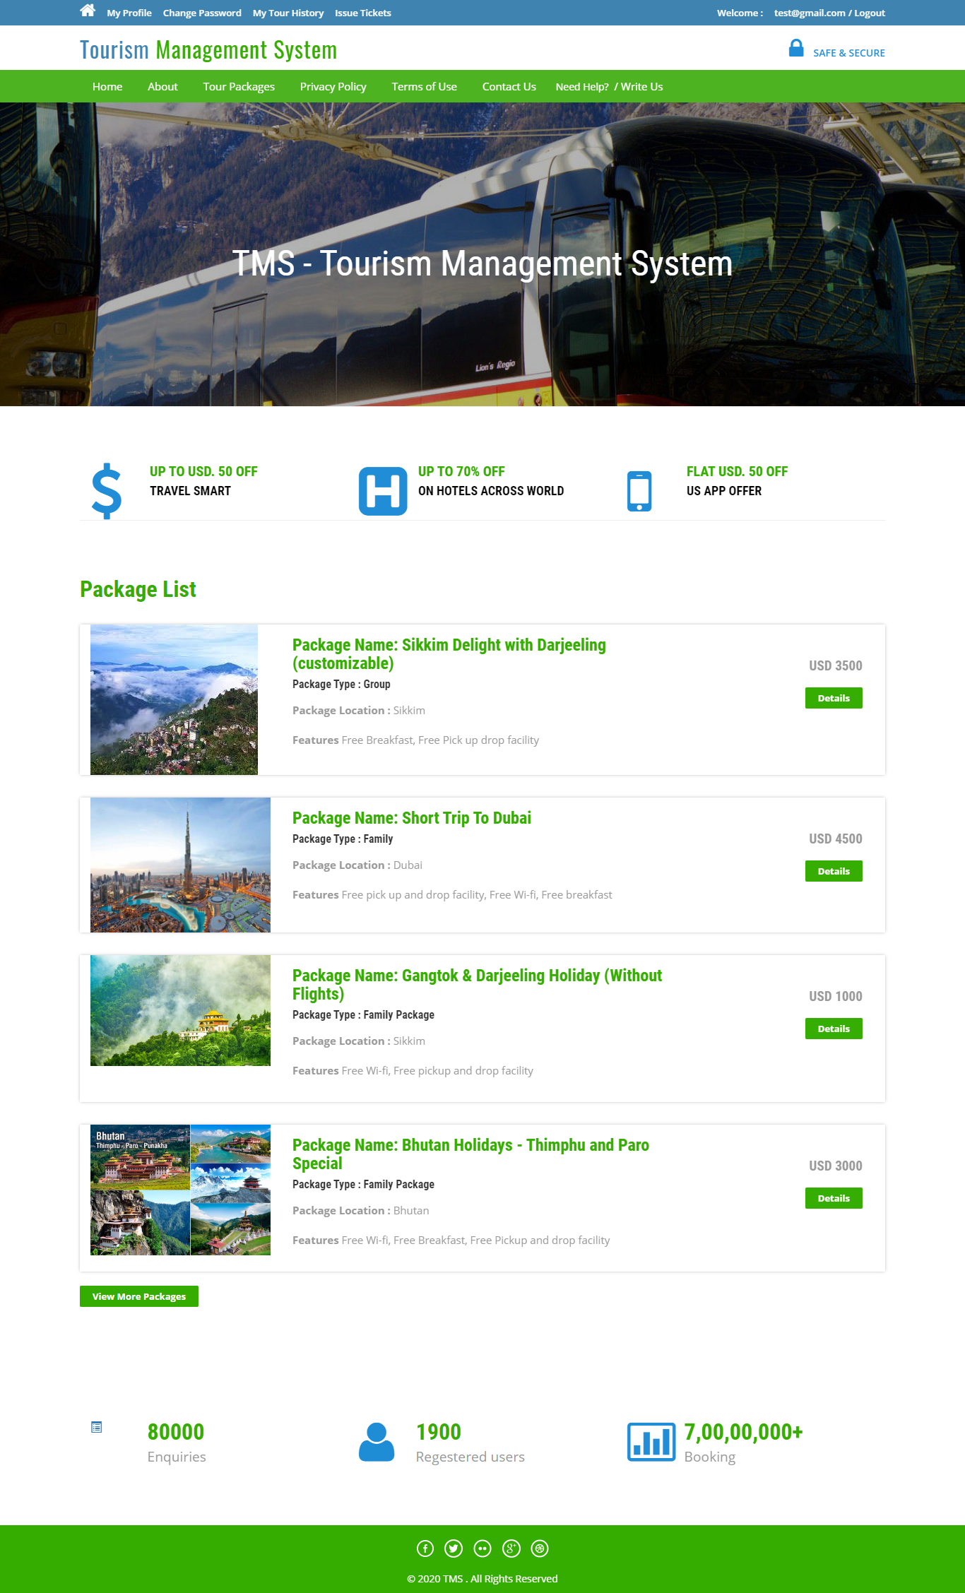

**About Us Page**



**Contact Us Page**

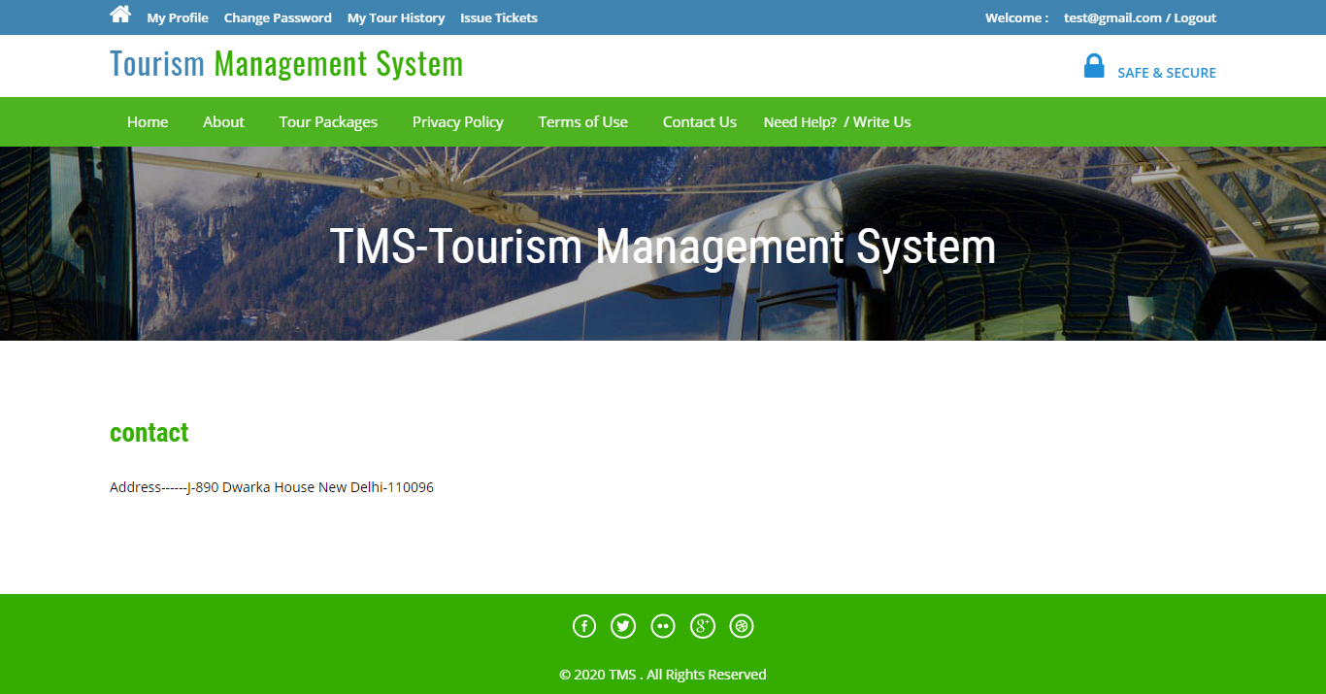

**Travels Packages**



**Privacy Policy**

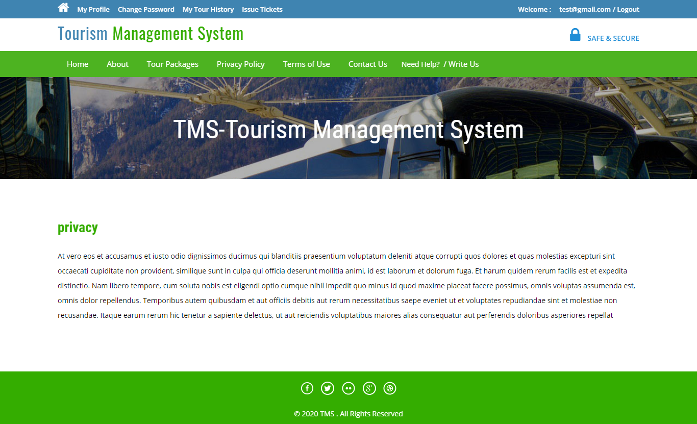

**Terms of use**



**Need Help Page**

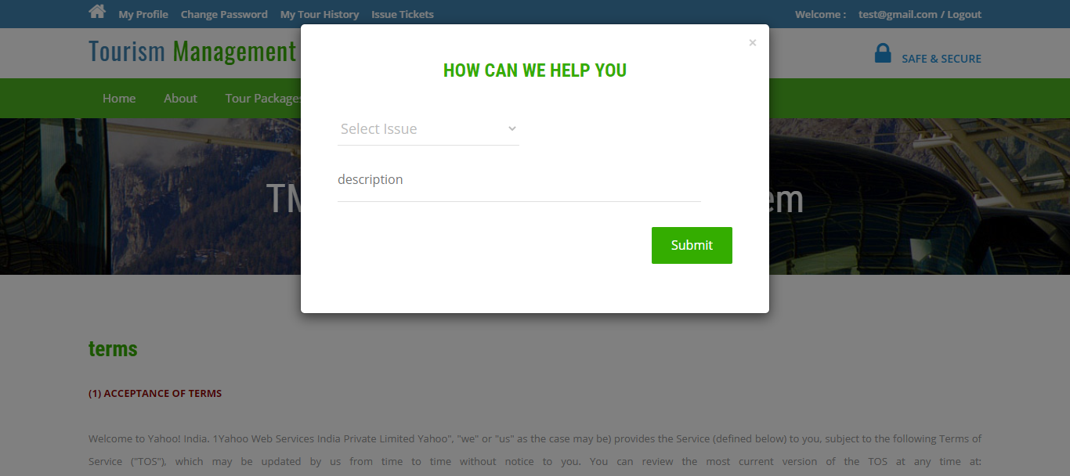

**User Profile**

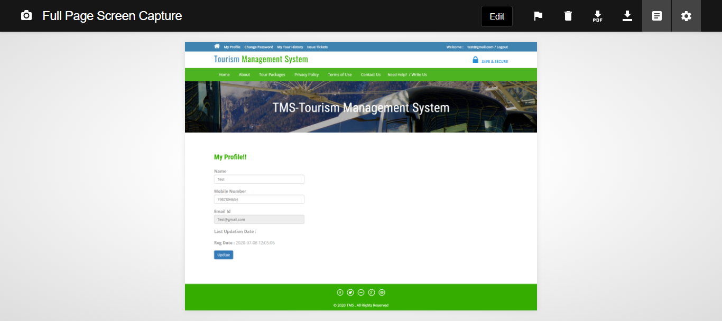

**Change Password**



**User Tour History**

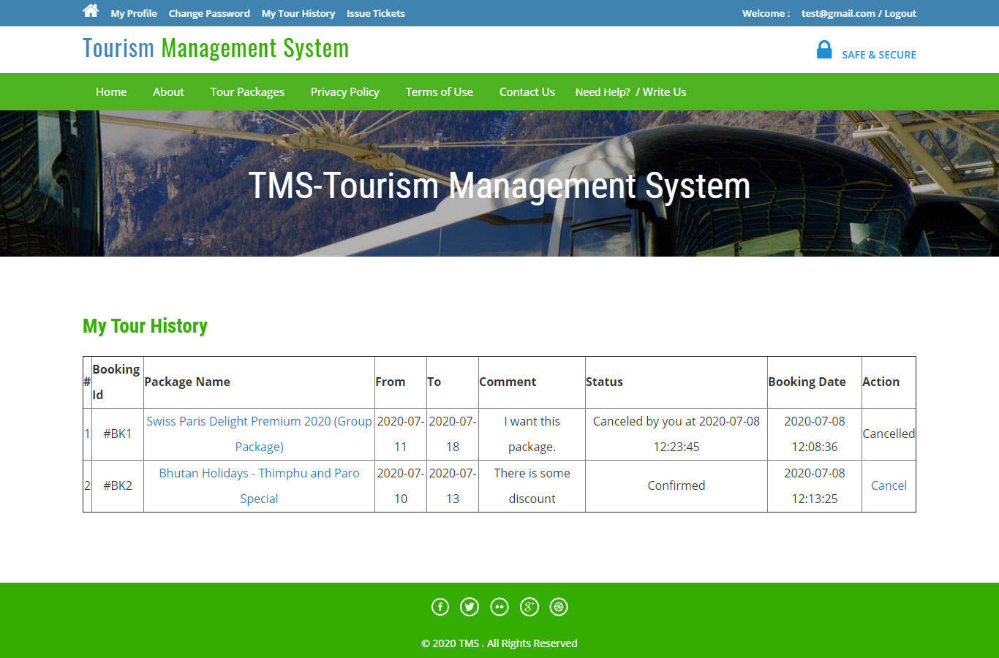

**User Issue Tickets**

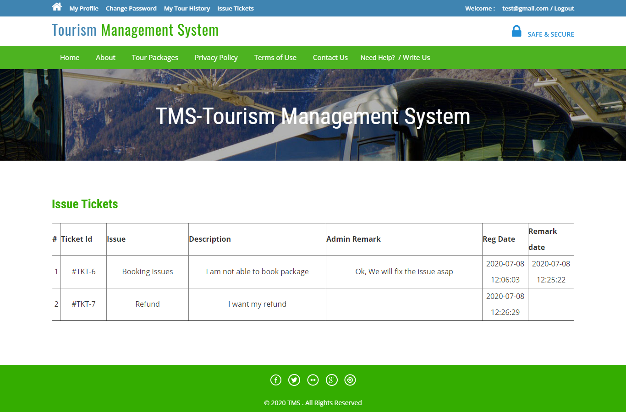

**User Sign Up**

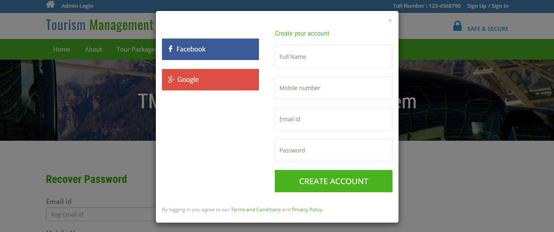

**User Sign in**

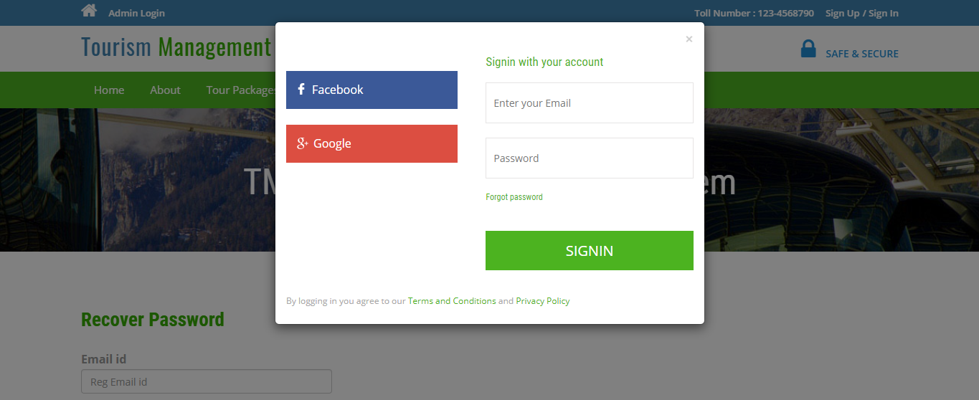

**Forgot Password**

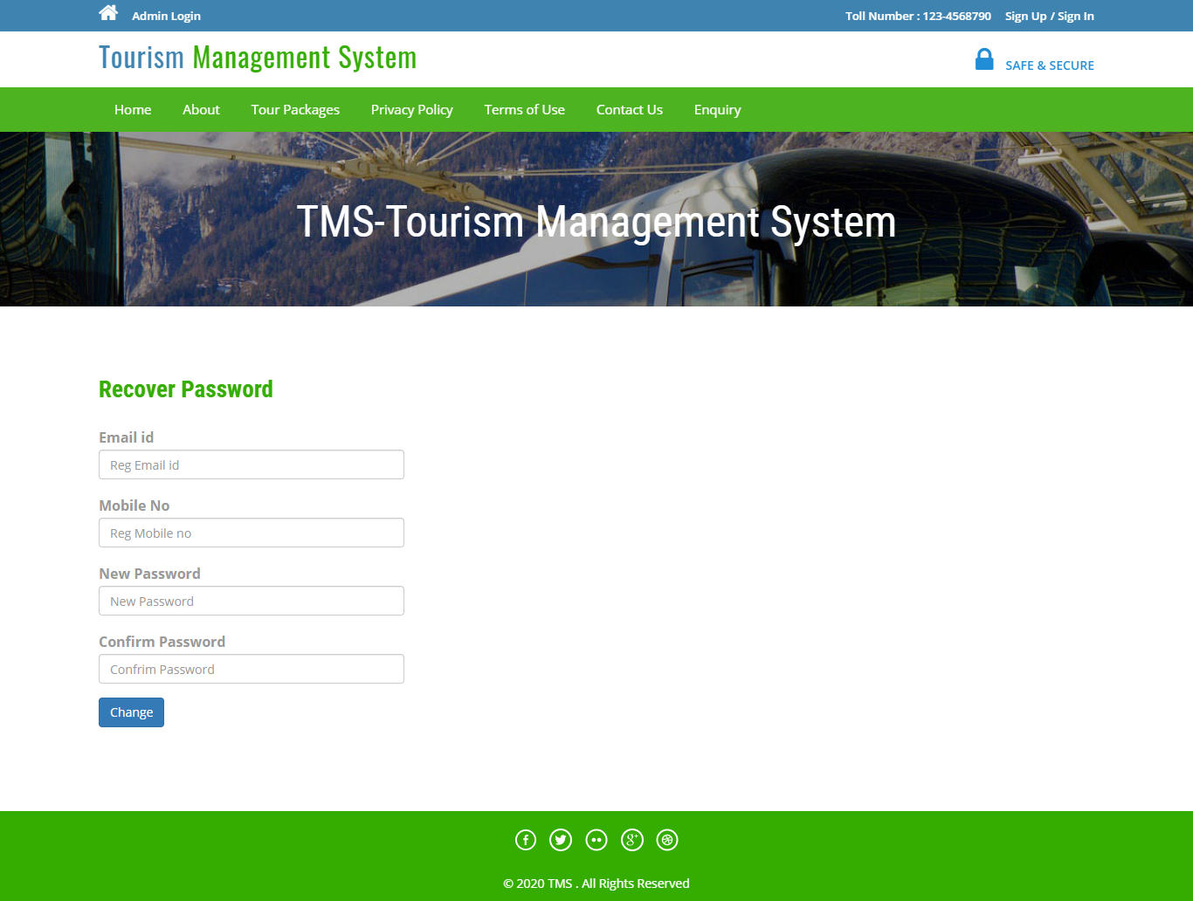

**Admin Login**

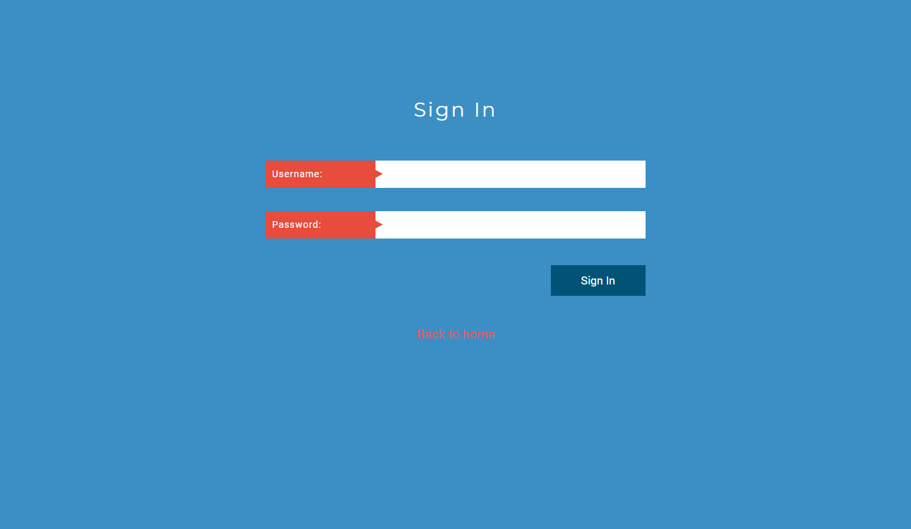

**Dashboard**

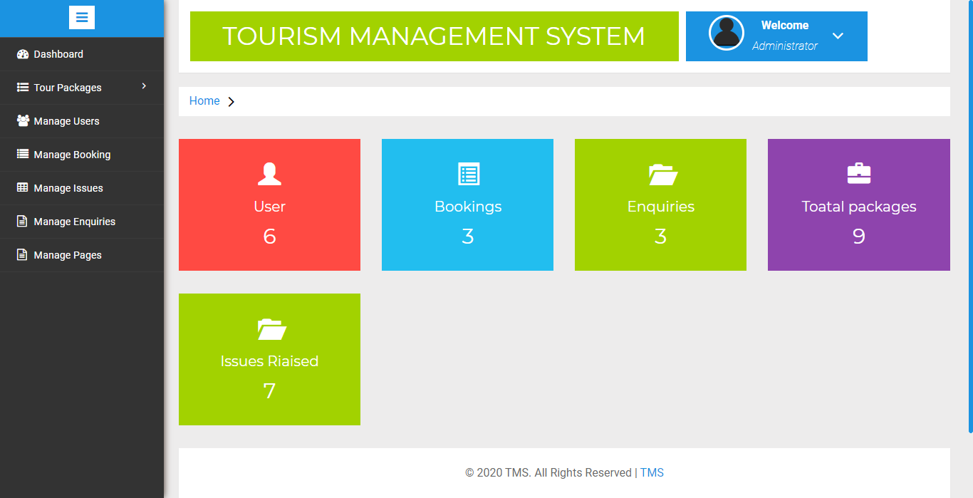

**Create Package**

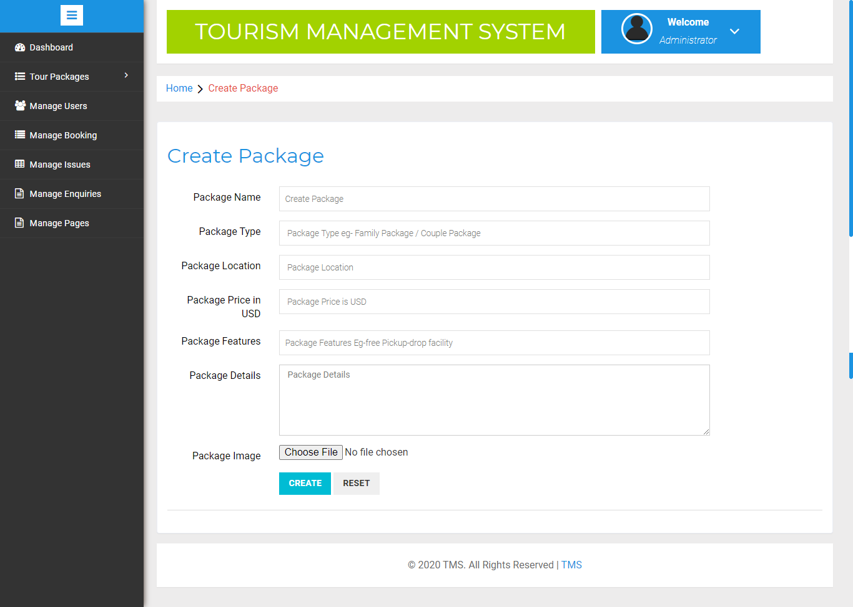

**Manage Package**

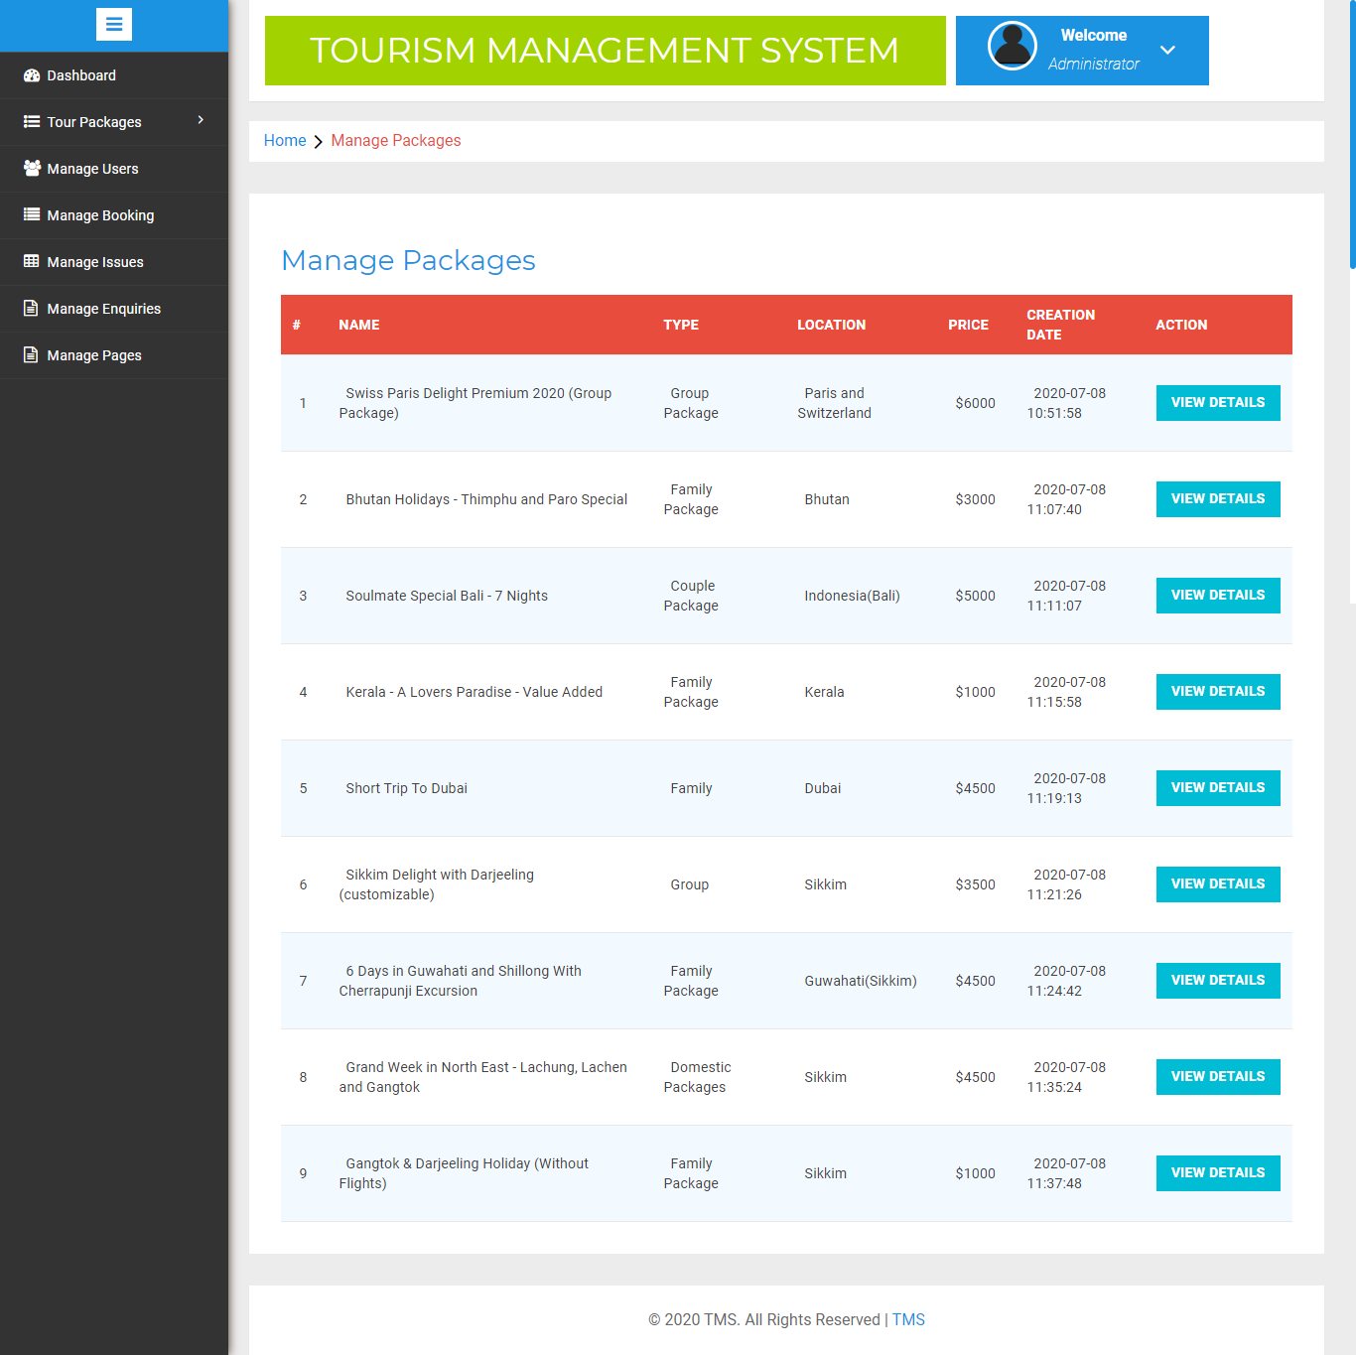

**Update Package**

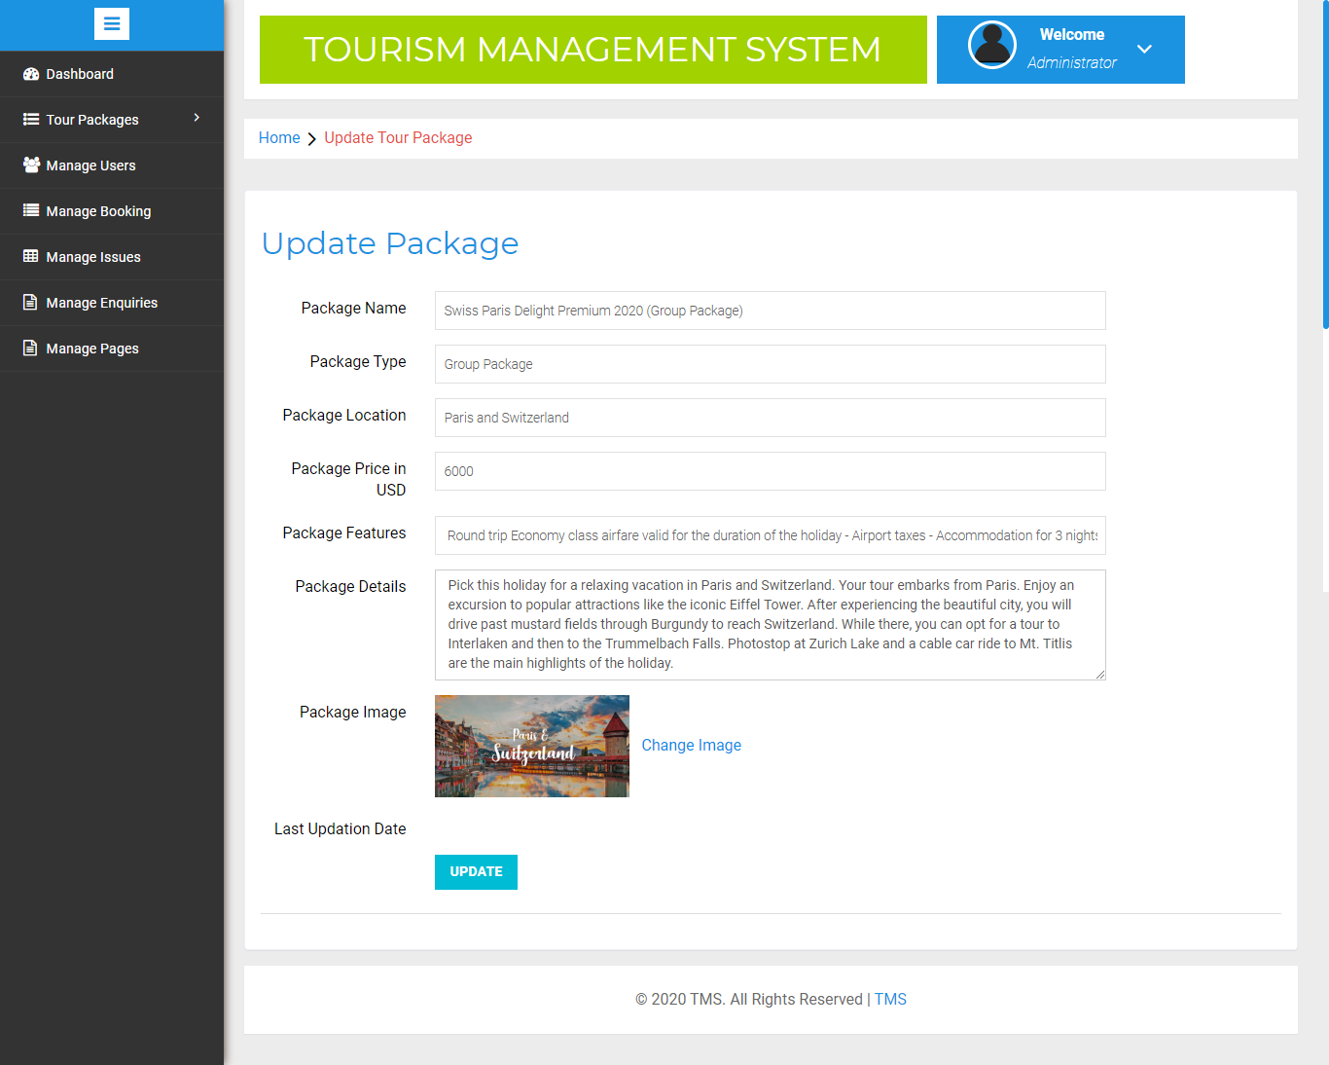

**Update Image**

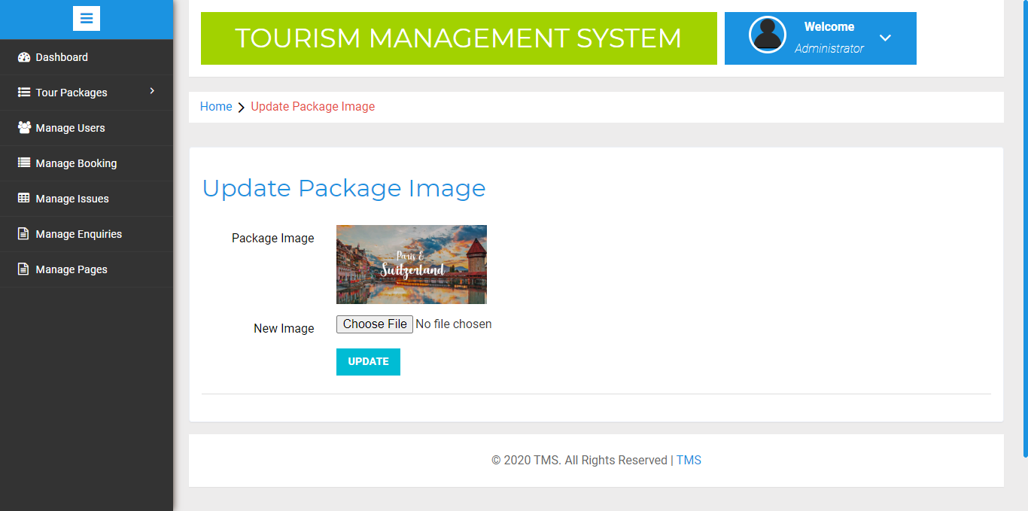

**Manage Users**

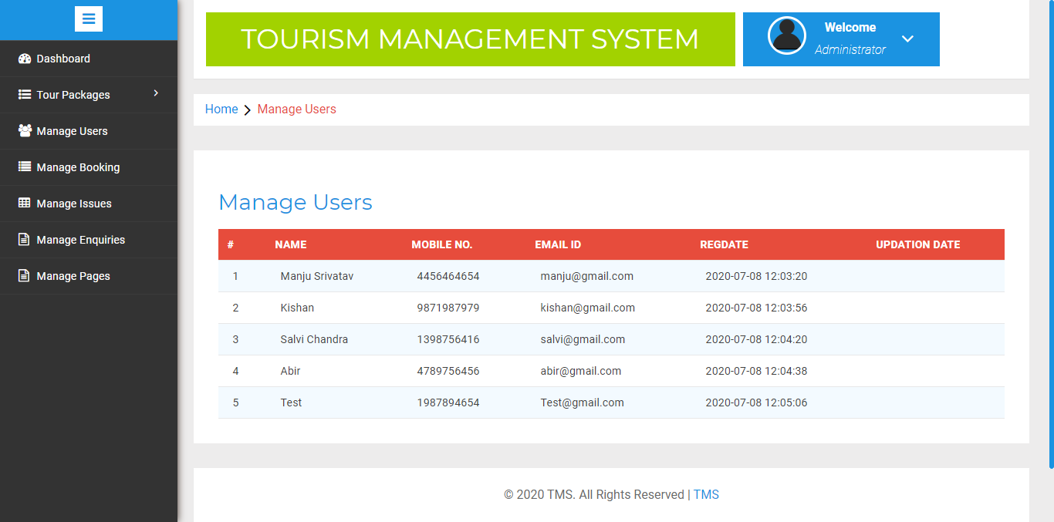

**Manage Booking**

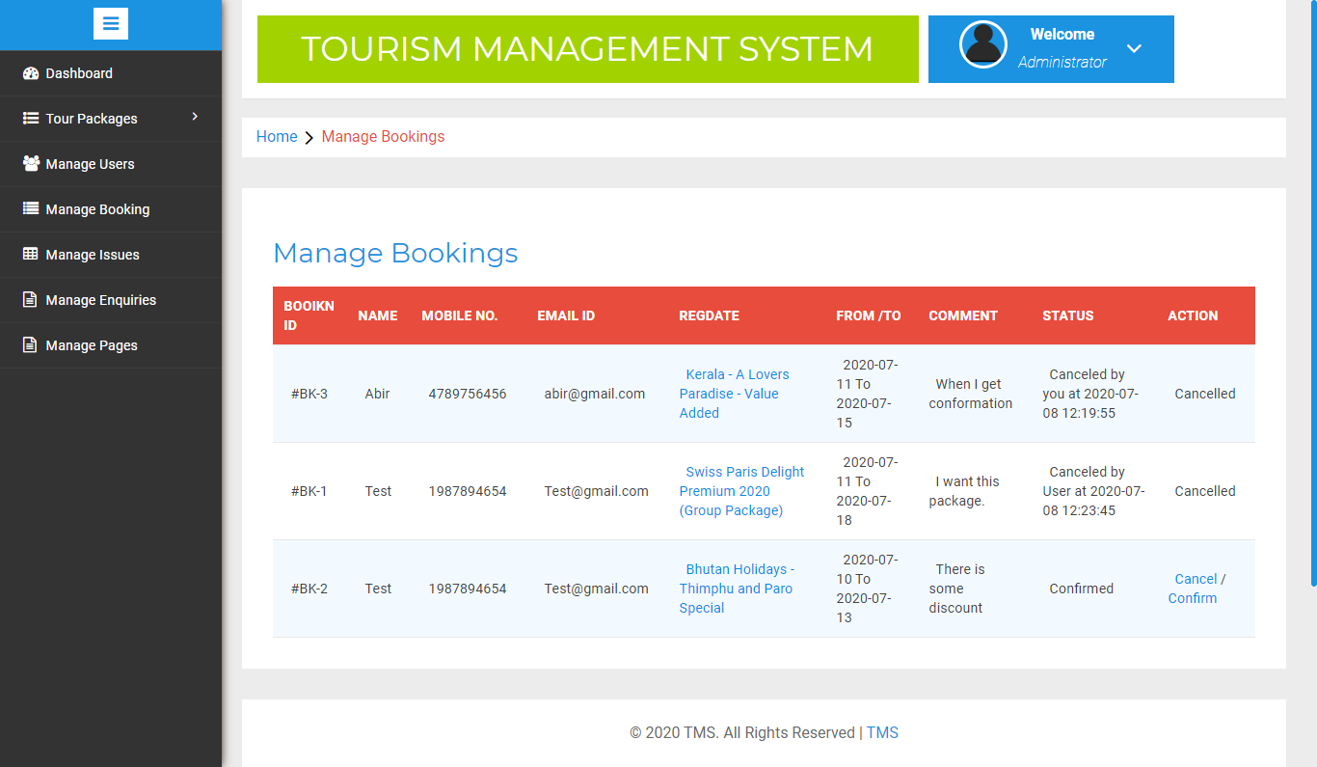

**Manage Issues**

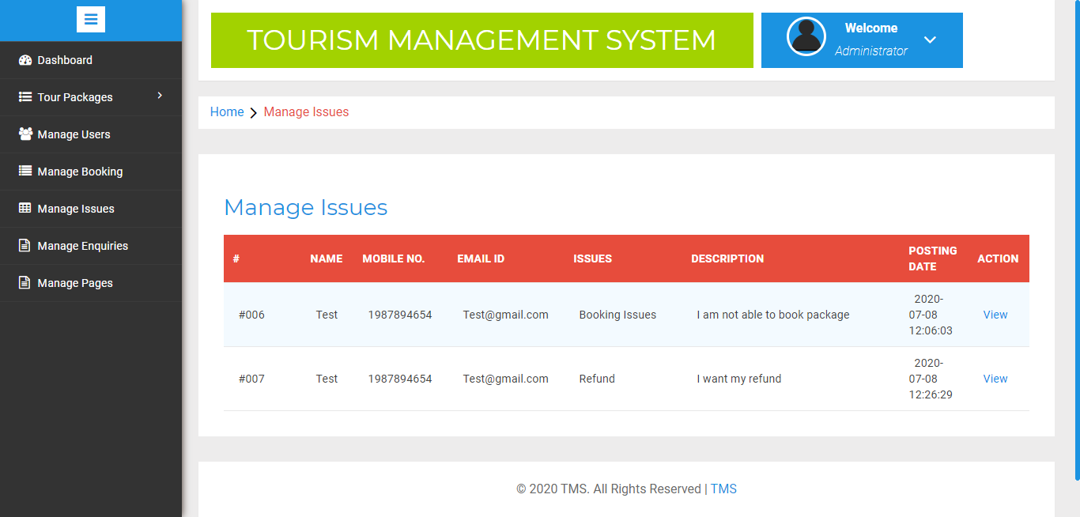

**Manage Enquiry**

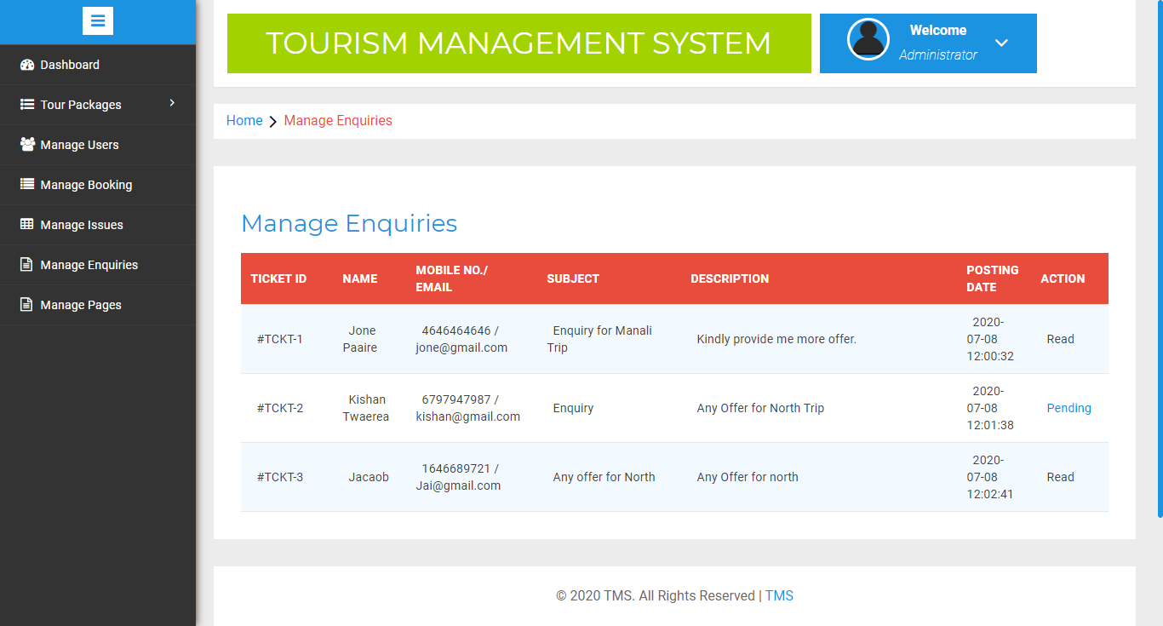

**Manage Pages**

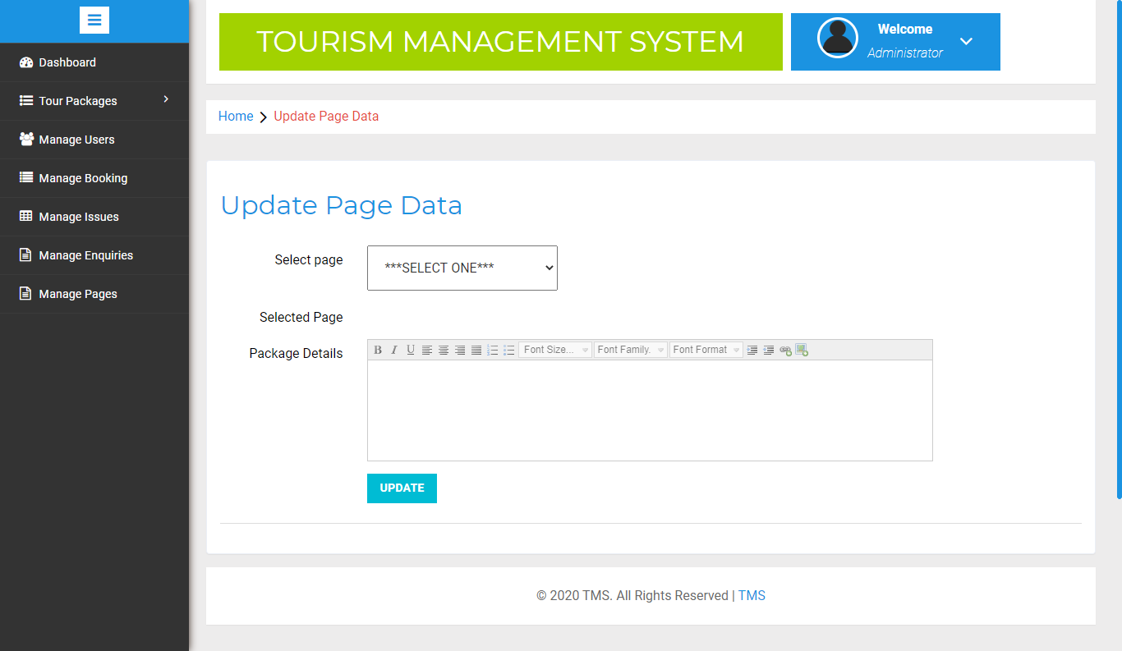

**Change Password**

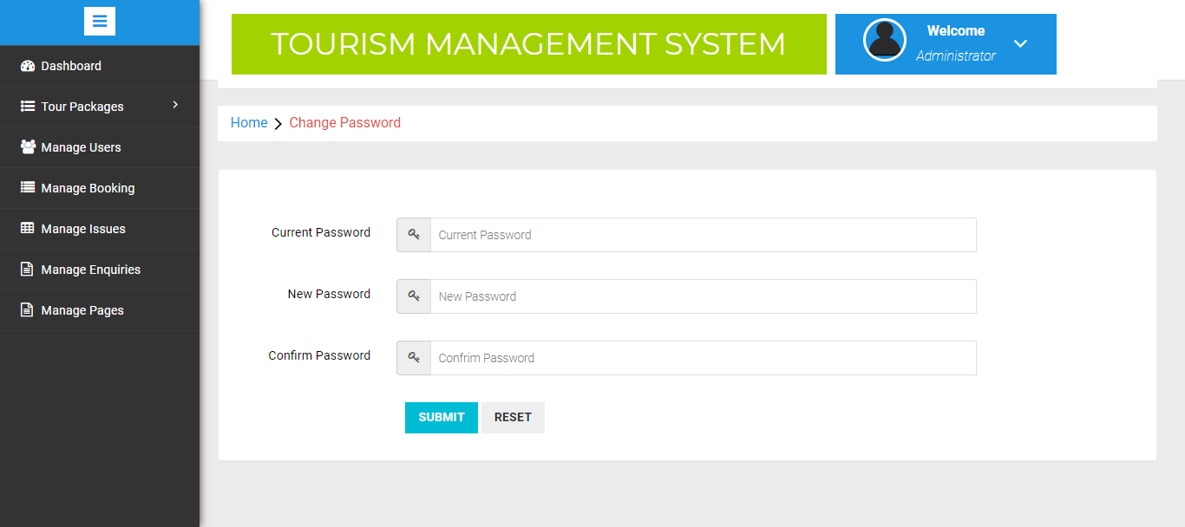

**CONCLUSION**

To conclude the description about the project : The project, developed using PHP and MySQL is based on the requirement specification of the user and the analysis of the existing system, with flexibility for future enhancement.

The expanded functionality of today’s software requires an appropriate approach towards software development. This hostel management software is designed for people who want to manage various activi-ties in the hostel. For the past few years the number of educational institutions are increasing rapidly.

Thereby the number of hostels are also increasing for the accommodation of the students studying in this institution. And hence there is a lot of strain on the person who are running the hostel and software’s are not usually used in this context. This particular project deals with the problems on managing a hostel and avoids the problems which occur when carried manually.

Identification of the drawbacks of the existing system leads to the designing of computerized system that will be compatible to the existing system with the system which is more user friendly and more GUI oriented.

**BIBILIOGRAPHY**

1. www.w3schools.com
2. *in.****php****.net*
3. *en.wikipedia.org/wiki/****PHP***

4 . www.hotscripts.com/category/**php**/

1. www.**apache**.org/
2. www.**mysql**.com/click.php?e=35050